Jesus Speaks On Turmoil in the U.S.
May 19, 2017

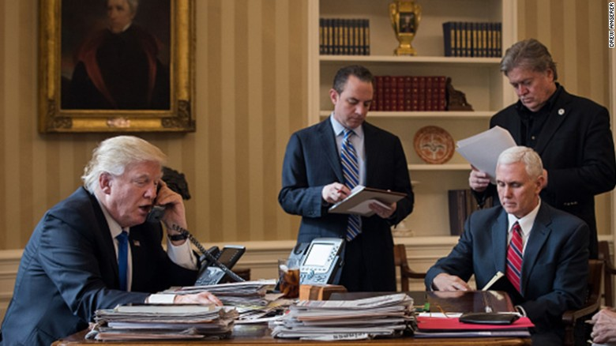
Lord Jesus, please awaken our hearts to be immersed in intercession as we build with the gifts you’ve entrusted to us.

This morning I was praying for my husband, who was experiencing a lot of pain. He's had an on-going condition that came up when he was healed of another condition. And as I prayed, I cried, asking for mercy. Just as I have told you, that the Lord is right there with you, I saw the Lord at my right hand, in the same posture of prayer I was in - and He, too, was crying. I thought perhaps my prayers were not being heard because of a sin I was not aware of. But then my husband spoke up and said that he was getting better, and the pain was leaving him.

Jesus explained, "Clare, it’s not about you; it’s about the world. And as things are going now, it does not look good. Rally your people around you for prayer and fasting. And as far as Ezekiel is concerned, I will always touch him when you pray, always. It’s My nature to be full of mercy and I weep with you over his condition, which is reminiscent of the world’s. So much is in need of restructuring, but the wicked powers are growing stronger and My people are growing weaker."

But Lord, isn’t the mandate to use their gifts a distraction and causing that - to be weaker in prayer?

He continued, "It could, if you fail to put in the prayer that is necessary. However, your obedience in using your gifts also counts for a great deal, even in the midst of this mess.

"The world is failing. Those who want war and death and destruction, those who are ignorant of their connections and ways of supporting evil - they make up a large part of this. They do not know what they are bringing upon themselves.

"And We are getting weary of contending with them."

And when He uses the word 'we' it refers to the Father, Son and Holy Spirit.

"But for the sake of those who do know and are gutting it out, We continue to come against this evil. However. Understand We will not contend with their ignorance forever.

"I understand about your weariness every day you awake to the same symptoms and fears for your husband. I understand and am here by your side, feeling the very same way. But he has made of himself an offering for the world, so you must understand We honor that commitment. Both of you, in fact, have participated in this suffering for the world.

"Yet there are breakthroughs…times when you make forward momentum.

"I need you to continue to record soothing music. Yes, ‘Over the Rainbow’ is a great song, but the climate for it is a bit dark. I need deep things now, deep, haunting and moving melodies. The climate also for donations is a bit oppressed, but I will see you through. There will always be something for you.

"Clare, you can always make improvements on your behavior and attitudes. But I want you to know, once and for all, this is not your fault. This is an offering, a suffering that I have allowed for both of you to have something substantial to offer Me, to turn the world around."

And that's what Ezekiel was saying, too. He was saying the same thing. 'It's not about you, Honey. It's what's needed right now in the world.' The Lord would continue to tell him, 'This is intercessory suffering. This is Simon's Cross.'

Then the Lord continued, "I am not saying it’s going to end prematurely."

By that He means, before the next two years are up.

"I am saying We are getting tired of contending. But for the sake of the saints on Earth who are pressing in and making their offerings, such as your own - for their sakes, We continue to fight and uphold what is right.

"It is a very dark night in the White House, much prayer is needed to reverse the climate there. And so you are suffering more than is usual. There is nothing wrong with presenting deep music at this time, for this is the climate among the people.

"You can finish the song. I am just saying this is a difficult time to celebrate. Yet, as you were musing in your mind…'We have to...'”

I was thinking this, this morning. 'Cause I worked on that song ‘Over the Rainbow’ last night. It's finally coming together. But it's such a happy, happy song, and I'm so much not in a happy, happy mood... And apparently the world isn't either. And I was thinking to myself, 'You know? I think we have to be bi-polar Christians in this hour…enthusiastic about creativity and serious about suffering for righteousness sake and praying.

The Lord continued, "That’s very cute and accurate as well, since you are building and creating with one hand and fighting the good fight with the other."

So I started to say, 'Sometimes...'

And He cut me off, before I could get the words out.

Jesus continued. He said, "I know, don’t say it. I will give you the strength. Clare, what I have said to you before has not changed anything. I am not one to say 'yes' one moment and 'no' the next."

And that's an interesting point, because He's made some promises to Ezekiel and I that I'm standing on.

"And as far as your question to Me goes, about the president's first three months in office. First of all, the time I quoted you was not to be taken scientifically exact to the day and hour. What has happened is that he has a strong support system and team that is in total agreement with him about the agenda for this nation. And that's a big accomplishment for his first 90 days. There was much turbulence in the beginning over that, but now he has key individuals who are not selling out on him. And so that makes forward momentum in a climate of severe opposition much smoother and more viable.

"With the elections coming up, I wish for all to rally around him and support him with your votes to give this country a chance at an integrated core government. These upcoming elections are very important. Very, very important. Please. Show your support by prayer, fasting and casting your vote."

Here what He is speaking about are special elections to the House and Senate, state by state, to be held at different times over the spring, summer and fall, to replace those in the House and Senate who have retired, died or been given assignments in Washington with the Federal government. So, those elections are coming up and they're local elections. So you might want to keep an eye on that, and support what's going on with those elections. Pray behind them.

Jesus continued, “There is hope. It is not hopeless. What looks hopeless is the smoke-screen thrown up by the elite sector in reaction to Donald winning the presidential race, as they are still trying to unseat him. But he is moving ahead in a very focused way in spite of the turmoil. And I am with Him.

"So, this is to say, your suffering over your husband’s infirmity is an offering to Me. Do I not relieve him when you pray? Yes, in every way I restore him. He is understanding what this is about and very accepting. I need you also to be My little lamb.

"Remember, when you cry, I cry. I am here for you, we are doing this together, My dear one. We are doing this together, all of us. The great cloud of witnesses is with you as well."

